# http://www.captechu.edu/files/ctu-gif.gif

CT152

UNIX/Linux Crash Course

Please complete this lab on the Ubuntu Server that I have setup for this course. Take a screenshot of each step which shows the command and result (if applicable). Return the lab

1. Logging in

Login to the server using an SSH client with the following information.

>ssh firstnameLastame@198.199.80.230

Your default password will be “password”.

1. After you login, change your password with the following command

You will be requested to type in your old password “password” and then a new password. Be sure to store your new password somewhere safe.

1. Moving Around – Linux File Structure

cd, ., ..

1. Getting help with the “man” manual command

The “man” command can be used to get help on the system.

>man

“man man” will take you to the help file for the manual. The “q” button will exit the manual.

>man ls

>man pwd

>man grep

>man sed

1. Showing contents of directory

>ls

>ls -lrt



1. Text Editing with Nano

Nano is a text editor that ships with some versions of Linux/UNIX. If it is not installed, it is typically very easy to install it – just search for installation instructions for your distribution.

>nano filename

Nano provides keyboard shortcuts to perform operations at the bottom of the screen.

Create a file with some text and save it as “testFile.txt”. Note that file extensions are meaningless to the UNIX operating system, but can be used by application programs.



1. Location of Executables

Navigate to the /bin directory. This is where most of the executable programs (commands) are stored on the server. Verify that you can find the following programs: grep, sed, awk, nano, vi, wc, python3, pwd, passwd, perl

Note that some commands (for example, cd) are built into the shell, they do not exist as independent programs – we call these internal programs.

1. Date/Cal

Execute the following commands and record the output:

>date

>cal

1. What Shell am I running?

There are different shells available to communicate with the system (Bourne Shell, Bourne Again Shell, C Shell, etc.) – they will reside in the /bin directory.

>echo $SHELL



1. What processes are running?

Will show all of the processes running on the server (and details).

1. Sending and retrieving mail (You can skip this step).

1. Piping commands

cmd1|cmd2

Send the output from one command to the input of the other command.

Simple example:

>cat longFile.txt | less



Will allow you to stop through the file without printing all of it (where longFile.txt is a file with many lines of text).

1. Who – what other users are on the system

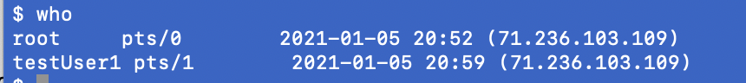



1. Saving your command history

>history > fileForHistory.txt



1. Tar archive of files

Where the .gz file is the archive and “testUser1” is the directory to archive.



1. Download of tar archive with FTP

1. Invoking Perl and Python

>perl -v

You can create a simple hello world program in perl using Nano to create a text file that includes

print “hello world\n”

Then execute the program with:

>perl testFile.txt

>python3

exit() will get you out of the python environment.

1. grep/sed/awk demonstration  
   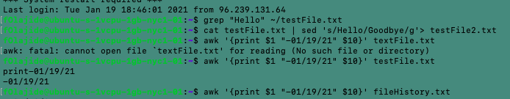

Package Manger

